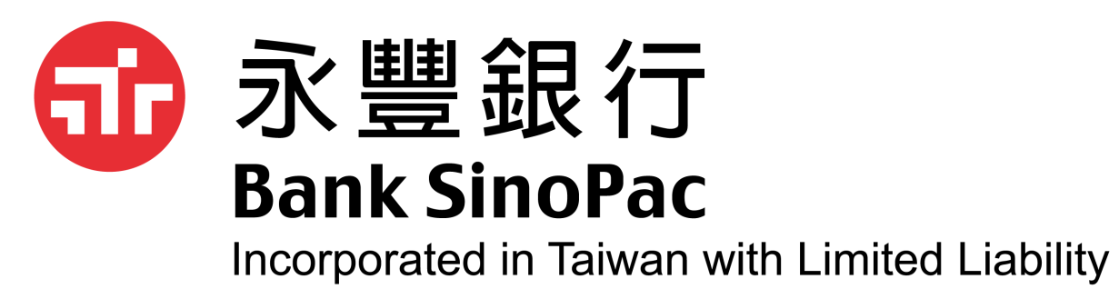
【可持續發展定期存款計畫】
經獨立第三方認證機構鑒證*
計畫目的
- 為響應香港2050年前實現碳中和目標，以及履行金融機構對於可持續發展的共同目標，自2023年6月1日起永豐銀行香港分行推出「可持續發展定期存款計畫」。
- 為支持在環境保護、可再生能源、效能提升、循環經濟系統等具綠色、社會效益之相關產業，與客戶共同實踐ESG理念。
計畫内容（計畫名額有限，額滿即止）
適用客戶： | 永豐銀行香港分行企業戶、理財客戶
資金支持產業： | 可再生能源、效能提升、循環經濟系統、環境保護等
起存金額： | 新資金美元（50萬） 、新資金港幣（390萬）
存款期限： | 3個月、6個月
定期利率： | 個案議價訂定
受理方式： | 請洽詢所屬客戶經理

註：*此計畫已經獨立第三方專業認證機構進行鑒證，並發出發行前鑒證報告。

推廣優化條款及細則：
- 本專案均受相關條款及細則約束，詳情請向所屬客戶經理查詢。
- 有關客戶的申請必須符合永豐銀行香港分行的要求，本行保留隨時修訂、暫停或取消本專案。如有任何爭議，本行擁有最終決定權。
- 本專案定期性存款到期前如遇本行牌告利率調整時，依本專案已開立定期存款之利率仍維持不變，不隨牌告調整。
- 本專案計畫名額有限，採先到先得原則辦理，額滿即止。
Sustainable Development Time Deposit Scheme
Certified by an independent verifying third party*

Scheme Purpose
- In participating to achieve carbon neutrality before 2050 in Hong Kong and to achieve the common goals of financial institutions for sustainable development, Bank SinoPac Hong Kong Branch has launched a sustainable development time deposit scheme since 1 June 2023.

- In supporting industries in renewable energy, efficiency improvement, circular economy systems and environmental protection etc. producing green and social benefits and supporting the implementation of ESG framework with our clients together.

Scheme Detail (limited quota applies)
Target Customer: | Bank SinoPac Hong Kong Branch corporate & wealth management clients
Industry being supported： | Renewable energy, efficiency improvement, circular economy systems and environmental protection etc.
Minimum deposit amount： | New funds in the amount of USD500,000 or HKD3.9 million
Deposit tenor： | 3-months, 6-months
Interest rate： | Upon negotiation
Application channel ： | Please contact one of our customer relationship managers

Note: *This scheme is certified by an independent verifying third party and an assurance report on pre-issuance has been issued.

General Terms:
- The above scheme is subject to our terms and conditions. For details, please contact one of our customer relationship managers.

- The applications to be submitted by our customers need to satisfy our requirements. We reserve the right to amend, suspend or terminate the above scheme. In case of any dispute, our decision shall be final.
- If our listed interest rate is adjusted before the maturity date of the time deposit, the interest rate of the time deposit made will remain unchanged without referring to the interest rate adjustments.
- Limited quota applies in the above scheme and it is available on a first-come-first-served basis.
- Should there be any discrepancy between the English and Chinese versions of this promotion material, the Chinese version shall prevail.

